Bikini Incision Total Hip Replacement
A cosmetically positioned anterior hip replacement incision designed to follow natural skin lines

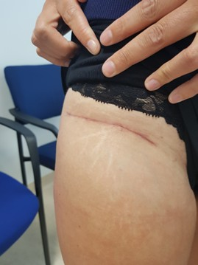
In some patients undergoing direct anterior hip replacement, Dr Paul Harvie may utilise what is commonly referred to as a bikini incision. In this technique, the skin incision is positioned along the natural crease of the groin, often referred to as the “bikini line”. By following the natural skin folds, the resulting scar may become less noticeable once healing has occurred.

The bikini incision relates primarily to the orientation and position of the skin incision, rather than altering the underlying hip replacement procedure itself. The hip joint replacement is still performed using established surgical techniques designed to replace the damaged ball-and-socket joint with prosthetic components.

Dr Harvie performs hip replacement surgery using contemporary surgical approaches, including the direct anterior approach, where the hip joint is accessed from the front of the body. During this approach, the surgeon works between natural muscle planes to reach the hip joint.

Whether a bikini incision is appropriate depends on several factors, including the patient’s anatomy, the condition affecting the hip joint, and overall surgical planning.

During consultation, Dr Harvie will assess each patient individually and discuss the most appropriate surgical approach based on your specific condition.

LEARN MORE ABOUT TOTAL HIP REPLACEMENT SURGERY

